Software Requirements Specification - Job Portal System
Submitted By,
Sruthy Ratheesh
Shinsina

Table of Contents
- Introduction 3

1.1 Purpose 3
1.2 Scope 3
1.3 Objectives 3

- Functional Requirements 5

2.1 Primary actors of the system 5
2.1.1 Job Seeker 5
2.1.2 Job Provider 6
2.1.3 Platform Admin 7
2.2 Use Case Diagram 8
2.2.1 Job Seeker 8
2.2.2 Job Provider 9
2.2.3 Platform Admin 10
2.3 User Stories 11
2.3.1 Job Seeker 11
2.3.2 Job Provider 12
2.3.3 Platform Admin 13
2.4 Business Process Diagram 14

- Non-Functional Requirements 14

3.1 Performance Requirement 14
3.2 Reliability and Availability Requirement 16
3.3 Security Requirements 16
3.4 Usability Requirements 16
3.5 Scalability Requirements 16
3.6 Maintainability Requirements 16
3.7 Portability Requirements 17
3.8 Backup and Recovery Requirements 17
3.9 Compliance Requirements 17
3.10 Audit and Monitoring Requirements 17
- Technical Requirements 17

4.1 Hardware Requirements 17
4.2 Software Requirements 18

- Conclusion 18

- Introduction
A job portal is an online platform that connects job seekers with employers, facilitating the recruitment process by allowing users to search for jobs, post vacancies, and manage applications.

1.1 Purpose
The purpose of this SRS document is to describe the functional and non-functional requirements for the Job Portal System. This system will allow job seekers to search and apply for jobs, and employers to post and manage job listings. The portal will serve as a bridge between job seekers and recruiters.

1.2 Scope
The Job Portal System is a web-based application that will:
- Enable job seekers to register, create profiles, upload resumes, apply for jobs, build resume and communicate with the job Provider.
- Allow employers to register, create profiles, post job openings, review applications, shortlist candidates, chat with the applicant and add the selected candidate as a company member after clearing the interview.
- Provide an admin module to monitor system activities and manage users.
- Improve the hiring process by automating job searching and application management.
- Faster way to apply for a job.

1.3 Objective
The objective of the Job Portal System is to create a platform that connects job seekers with employers, streamlining the recruitment process. The system aims to provide a userfriendly interface, secure data handling, and efficient management of job-related information. It is designed to be accessible to job seekers from any background, allowing them to search for current job openings, register and apply for positions. Employers can post job openings, view applications, and shortlist candidates, ensuring a smooth and effective hiring process. The Employer can make the candidate as a company employee after selecting the candidate. The system also incorporates features such as personalized filters, alerts, and resume analysis to help users discover opportunities that align with their skills and aspirations.

- Functional Requirements
Here are the functional requirements of the Job Portal System
  - Primary actors of the system
The Primary actors of the system are:
    - Job Seeker
A Job Seeker is a user of the job portal system who is looking for employment opportunities. Their main goal is to find, apply for, and track jobs that match their skills, experience, and career interests. In a job portal system, the Job Seeker interacts with the platform to perform activities related to job searching and career management. They are one of the primary stakeholders, along with Job Provider and Platform Admin.
Key Functions and Features of Job Seeker
Registration, Login and Profile Creation: The job seeker Register, Login and creates a personal profile. Profile includes personal details (name, contact info), education, experience, skills, and resume/CV upload.
Resume Management: Upload, update, or create a resume directly within the portal. System allows auto-formatting or AI-enhanced resume building.
Search Job, Save Job, and Apply for a Job: Search for available jobs using filters such as Job Title, Location, and Company Name etc. Save the interested job for later use. Apply to jobs directly through the system. Attach resumes or cover letters as needed. Receive confirmation and track application status.
Get Notifications and Alerts: Get email or in-app notifications about new job postings, application updates, or recruiter messages.
Chat with Job Provider / Platform Admin: Message or respond to recruiters/ Platform Admin regarding interviews or additional information or any other concerns.
Calendar: Seeker can save upcoming events in the calendar so that the system will notify the event.
    - Job Provider
A job Provider of the Job Portal System is an individual, company, or organization that offers employment opportunities and uses the system to post job listings, search for suitable candidates, and manage the recruitment process.

Key Functions and Features of Job Provider
Registration, Login and Profile Creation: The job Provider Register, Login and creates a Company profile.
List out/update/Delete Job Posting: A Job Provider can list out new job postings, update or delete an existing job posting.
Search for a suitable candidate: The Job Provider can search a suitable candidate based on the qualification, year of experience etc.
Accept/ Reject an Applicant: The Job Provider can accept/reject a candidate for the interview process.
Update the status mode of the Interview: The Job Provider has the ability to modify the interview mode, choosing between online and offline options.
Send Mail/ Call Candidate: After the interview, the Job Provider should communicate the outcome to the candidate via email or phone
Add Candidate as an Employee: After the selection process is completed, the Job Provider updates the system by adding the selected candidate as an Employee. This involves recording relevant employment details such as employee ID, position, department, date of joining, and contact information.
Chat with Job Seeker / Platform Admin: Message or respond to Job Seeker/ Platform Admin regarding interviews or additional information or any other concerns.
    - Platform Admin
A Platform Admin is the authorized user responsible for managing, monitoring, and maintaining the entire platform to ensure its smooth and secure operation. The admin has full control over both job seekers and job providers, as well as all system settings and data.
Key Functions and Features of Platform Admin
Login: The Platform Admin can Login to the system using predefined Credential.
Receive Notification of New Job Seekers/Providers/ Job Posting: The Platform Admin receives notifications whenever new Job Seekers or Job Providers register or a new job posting on the platform, allowing timely verification and approval.
User Management: The Platform Admin is responsible for User Management, which involves monitoring, controlling, and maintaining all user accounts within the Job Portal System. This includes both Job Seekers and Job Providers. The admin can view user details, verify registrations, approve or reject new accounts, and deactivate or delete inactive or fraudulent users. Effective user management ensures the platform remains secure, reliable, and free from unauthorized or fake accounts.
Approve/ Reject Job Provider: The Platform Admin has the authority to review, approve, or reject Job Provider for posting a job based on the platform’s policies and verification criteria to avoid fraudulence.
Add Predefined Set of locations/Skills: The Platform Admin can add and manage a predefined set of locations and skills within the system to maintain consistency and accuracy in job postings and user profiles.
Chat with Job Seeker / Job Provider: Message or respond to Job Seeker/ Job Provider regarding interviews or additional information or any other concerns.
  - Use case Diagram
2.2.1 Job Seeker
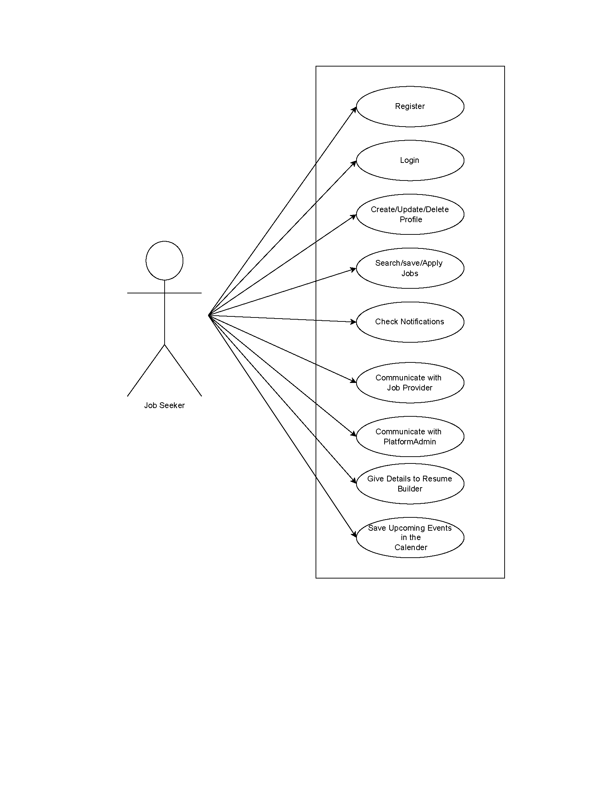

2.2.2 Job Provider
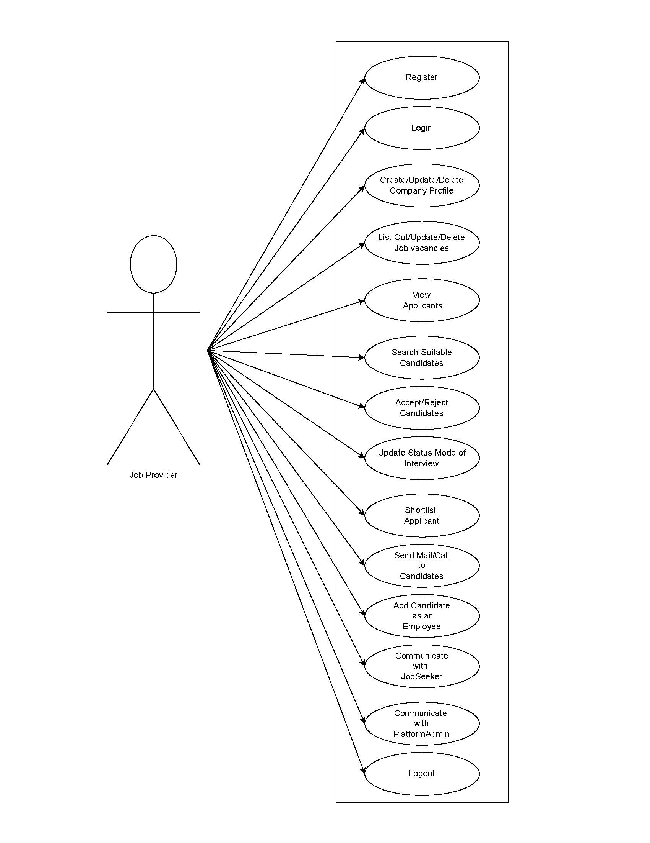

2.2.3 Platform Admin
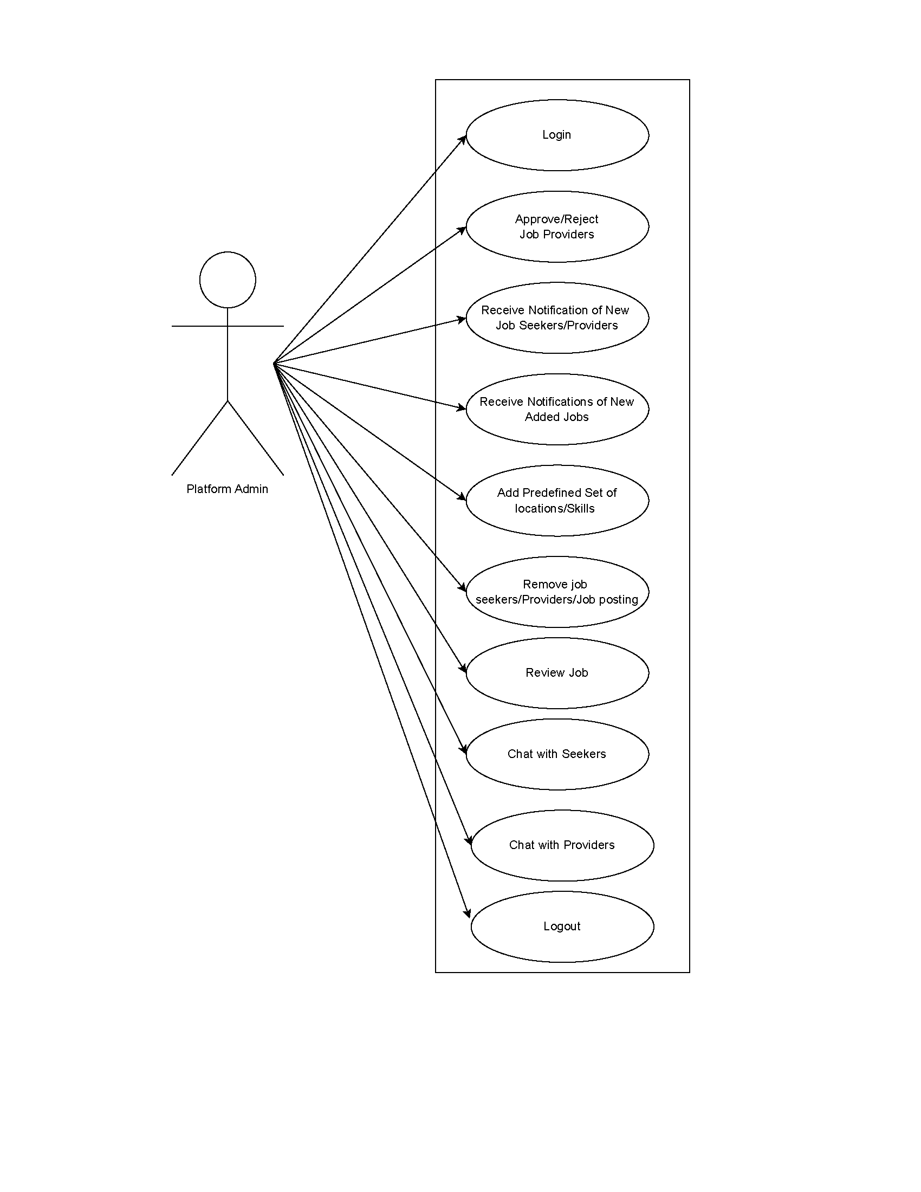

  - User Stories

    - Job Seeker
As a | Need to (Do some tasks) | So that I can (Get some results)
Job Seeker | Register into the Applications by entering details | Make my data available to job providers and use the system capabilities reserved for Registered users
Job Seeker | Login to the System by entering credentials | Enter into Application Apply for a job, view job providers and see my updates
Job Seeker | Create a profile | Apply for a job according to my qualification and experience
Job Seeker | Update profile | Apply for a job according to my qualification and experience
Job Seeker | Delete profile | Erase all my details from the job portal application
Job Seeker | Search for a job by company | Get a list of jobs according to my search and their details
Job Seeker | Search for a job by Location | Get a list of jobs according to my search and their details
Job Seeker | Search a job by category | Get a list of jobs according to my search and their details
Job Seeker | Save Interested Job posting for future | Apply for the same job later
Job Seeker | Apply for a job that suits my profile | Get a response from the job provider and get the further notification
Job Seeker | Check the Notification/Alert | Get a response from the job provider and get the further notification
Job Seeker | Communicate with a responsible person of the job provider Team | Get response from the respective person
Job Seeker | Communicate with a responsible person of the Platform Admin | Get response from the Platform Admin
Job Seeker | Give my details to System | Get a Resume which will highlight my profile
Job Seeker | Save the upcoming dates | Get alert for the upcoming event(eg: interview date)
Job Seeker | Log Out from job portal system | Exit from the job portal

    - Job Provider

As a | Need to (Do some tasks) | So that I can (Get some results)
Job Provider | Register into the Applications by entering details | Make my data available in Application and use the system capabilities reserved for Registered users
Job Provider | Login to the System by entering credentials | Enter into Application. Add job postings. Remove a particular Posting from the list. Update a particular job posting.
Job Provider | Create a Company profile | Post a job, view all the relevant candidate list , Choose appropriate candidates
Job Provider | Update Company profile | Post a job, view all the relevant candidate list , Choose appropriate candidates
Job Provider | Delete company profile | Erase all my details from the job portal application
Job Provider | List out job Postings.  Delete a particular job Posting | Get list of suitable candidate profiles.
Job Provider | Update a particular job Posting. | Get list of suitable candidate profiles.
Job Provider | Delete a particular job Posting | Get list of suitable candidate profiles.
Job Provider | View the new applicant profile | Get all the relevant details of the applicant
Job Provider | Search for suitable candidates using keywords(experience, qualification, gender) | Get list of suitable candidate profiles according to the search keywords
Job Provider | Accept candidate applications on the job portal. | Access their details and determine whether to move forward to the next step or not
Job Provider | Reject a candidate application from the job portal | Remove the candidate from the list
Job Provider | Update status of the interview process (online, offline) | Get response from the job seeker
Job Provider | Shortlist the applicant | Get the appropriate list of candidates
Job Provider | Give response to job seeker after the interview process. | Get response from the respective person
Job Provider | Send email or call the particular job seeker for the further follow-ups | Get response from the respective person
Job Provider | Add selected candidate as a company member | List and communicate with him as a company member.

Job Provider | Communicate with the job seeker | Get response from the respective person
Job Provider | Communicate with the Platform Admin | Get response from the Admin
Job Provider | Log out from Job Portal System | Exit from the job portal

    - Platform Admin

As a | Need to (Do some tasks) | So that I can (Get some results)
Platform Admin | Login to the System by entering credentials | Enter into Application
Platform Admin | Approve/ Reject Job providers before they list a new job on the platform | Ensure the quality of the job listing on the platform and prevent fraudulent job posting.
Platform Admin | Receives notifications of new job seekers | View details and number of newly added job seekers.
Platform Admin | Receives notifications of new job Providers | View details and number of newly added job Provider.
Platform Admin | Receives notifications of new job Posting from a job provider | View details of newly added job Posting.
Platform Admin | Add predefined set of Location to the System (Master Data) | List of Locations to be entered
Platform Admin | Add predefined set of Skill Set to the System (Master Data) | List of skill set to be entered
Platform Admin | Remove a job seeker/ job provider / a job posting from the job portal | Ensure the privacy and security of the Application
Platform Admin | Review Job Posting | Ensure the quality of the job post.
Platform Admin | Chat with Job Seeker | Get response from the particular Job Seeker
Platform Admin | Chat with Job Provider | Get response from the particular Job Provider
Platform Admin | Log out from Job Portal System | Exit from the job portal

  - Business Process Diagram

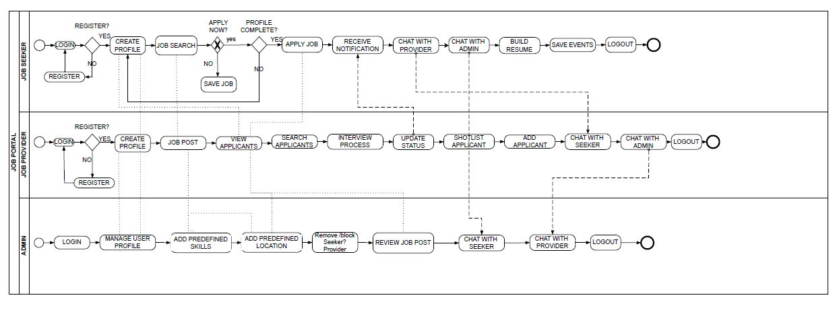

- Non-Functional Requirements
Non-functional requirements define the quality attributes, performance standards, and operational constraints of the Job Portal System. These requirements ensure that the system operates efficiently, securely, and reliably for all users — Job Seekers, Job Providers, and the Platform Admin.
3.1 Performance Requirements
- The system should respond to user requests within 2–3 seconds under normal load.
- It must be capable of handling multiple concurrent users without performance degradation.
- The database should efficiently process large volumes of job listings and user data.

3.2 Reliability and Availability
- The system should be available 24/7 with minimal downtime.
- In case of a server or network failure, the system should recover automatically without data loss.
- Scheduled maintenance windows should clearly communicated to users.
3.3 Security Requirements
- User data (personal details, passwords, resumes) must be encrypted both in transit and at rest.
- Secure authentication (e.g., via email verification or multi-factor authentication) must be implemented.
- Access control should ensure that only authorized users (Platform Admin, Job Seeker, and Job Provider) can perform their respective operations.
- Regular security audits should be performed to prevent unauthorized access and data breaches.
3.4. Usability Requirements
- The user interface should be simple, intuitive, and responsive for easy navigation.
- The system should be mobile-friendly, supporting both desktop and mobile browsers.
- Clear instructions, tooltips, and feedback messages should be provided for user actions.
3.5 Scalability Requirements
- The system should be designed to scale horizontally or vertically to support future growth in users and job listings.
- Cloud-based deployment or modular architecture should be considered for scalability.
3.6 Maintainability Requirements
- The system codebase should be well documented and modular to simplify debugging and updates.
- It should support easy integration of new features (e.g., AI-based recommendations, analytics).
- Regular updates should not disrupt system availability.

3.7 Portability Requirements
- The system should be deployable on various platforms (Windows, Linux, or Cloud servers).
- The web portal should be accessible through all major browsers (Chrome, Edge, Firefox, Safari).
3.8 Backup and Recovery
- Automatic data backup should occur daily or weekly to prevent data loss.
- The system should support data recovery in case of corruption or failure within a defined period (e.g., within 4 hours).
3.9 Compliance Requirements
- The system should comply with data protection laws (e.g., GDPR or relevant local policies).
- User consent must be obtained before collecting or storing personal data.
3.10. Audit and Monitoring
- The system should maintain activity logs for all user and admin operations.
- Logs should be stored securely and reviewed periodically for abnormal activities.

- Technical Requirements
The Technical Requirements define the technologies, tools, and system configurations needed to develop, deploy, and maintain the Job Portal System efficiently.
  - Hardware Requirements
Processor: Intel Core i5
RAM: 16 GB
Hard Disc: 1TB

4.2 Software Requirements
Operating System
- Windows 10 / Linux (Ubuntu, CentOS), AWS, Azure
Backend Technologies
- Programming Language: C#
- Database: Microsoft SQL Server
Frontend Technologies
- Languages: HTML5, CSS3, JavaScript
- Frameworks: Angular, Bootstrap

- Conclusion
The Job Portal System provides a comprehensive platform that efficiently connects Job Seekers with Job Providers, streamlining the recruitment and hiring process. The proposed System will create an efficient, user-friendly, and secure platform that bridges the gap between Job Seekers and Job Providers. This SRS document has outlined the system’s objectives, functional and non-functional requirements, technical specifications, and key modules that define how the platform will operate.
By implementing this system, the recruitment process becomes faster, more organized, and accessible, enabling Job Seekers to easily search and apply for suitable positions while allowing Job Providers to effectively post and manage job vacancies. The inclusion of an administrative module ensures proper monitoring, data security, and system maintenance.
Overall, the Job Portal System is designed to provide a reliable, scalable, and interactive environment that streamlines employment activities and enhances the experience for all users. The detailed requirements and design specifications presented in this document will serve as a strong foundation for the successful development, deployment, and future enhancement of the system.

